**DAILY ONLINE ACTIVITIES SUMMARY**

|  |  |  |  |  |  |  |  |
| --- | --- | --- | --- | --- | --- | --- | --- |
| **Date:** | **08/06/2020** | | | | **Name:** | **Sinchana K N** | |
| **Sem & Sec** | **IV sem & B section** | | | | **USN:** | **4AL18CS083** | |
| **Online Test Summary** | | | | | | | |
| **Subject** | | **Complex Analysis, Probability and Statistical Methods** | | | | | |
| **Max. Marks** | | **30** | | **Score** | | **18** | |
| **Certification Course Summary** | | | | | | | |
| **Course** | **Statistical Methods for Decision Making** | | | | | | |
| **Certificate Provider** | | | **Greatlearning academy** | **Duration** | | | **7 hours** |
| **Coding Challenges** | | | | | | | |
| **Problem Statement1:**Write a Java Program to check whether the given matrix is magic square or not.  **Problem Statement2:**C Program to Generate All the Set Partitions of n Numbers Beginning from 1 and so on. | | | | | | | |
| **Status: Executed** | | | | | | | |
| **Uploaded the report in Github** | | | | **YES** | | | |
| **If yes Repository name** | | | | **https://github.com/acchu1234sinchana/Lockdown_coding1** | | | |
| **Uploaded the report in slack** | | | | **YES** | | | |

Online Test Summary: 18MAT41 test was scheduled from 9:30am t0 10:10am .The portion for the IA was 2nd module there were 15 questions and the time assigned was 40 minutes the questions were mcq type.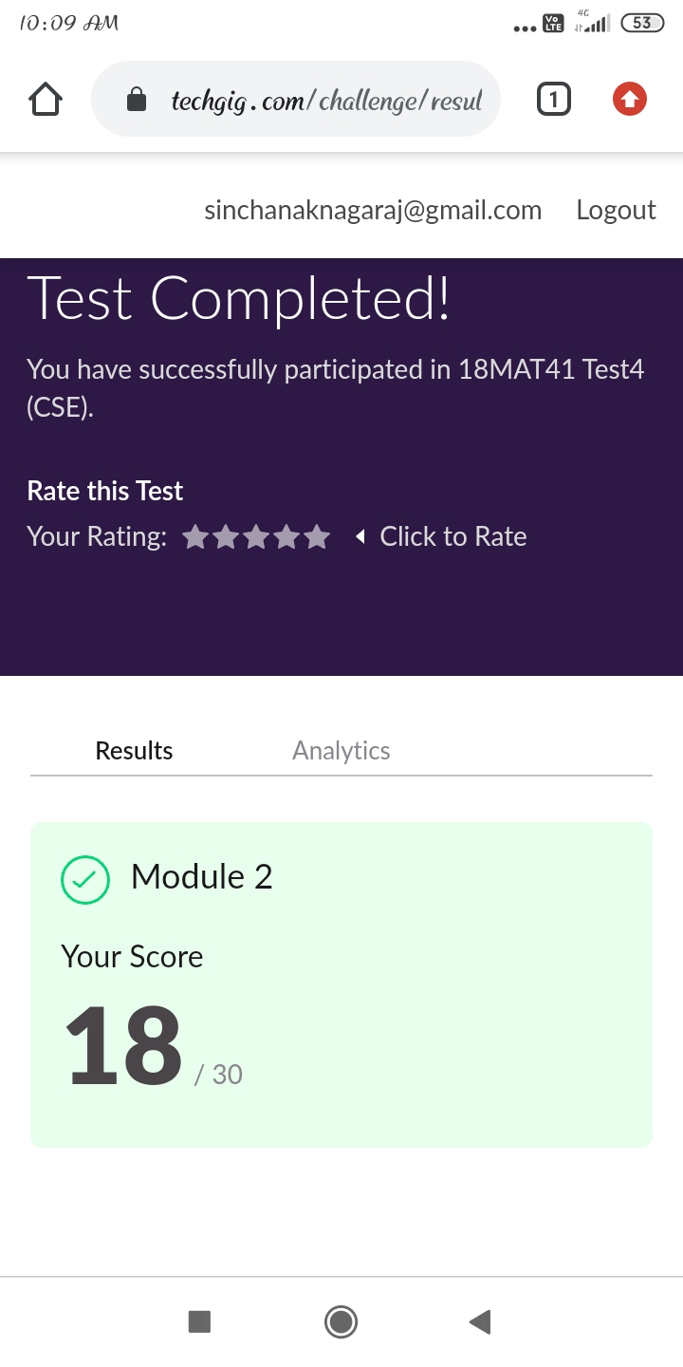

This is the snap shot of the test completed and the marks obtained.

Online Certification Course Summary: Today I learnt about Working with R - Part 1,Working with R - Part 2,Basics of Probability.

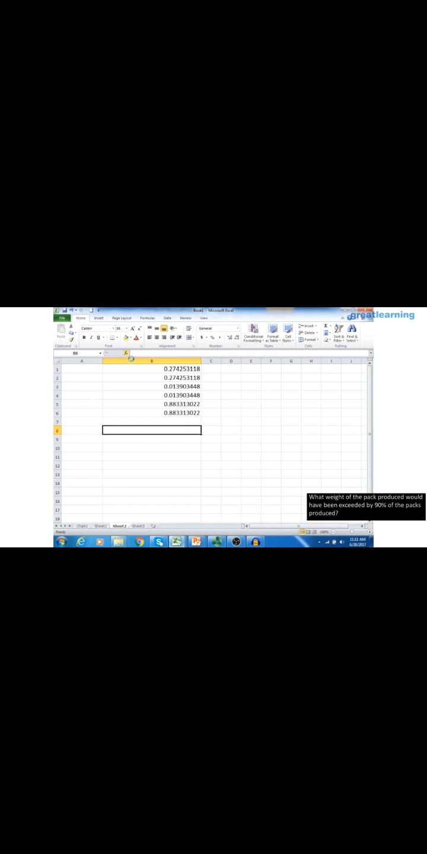

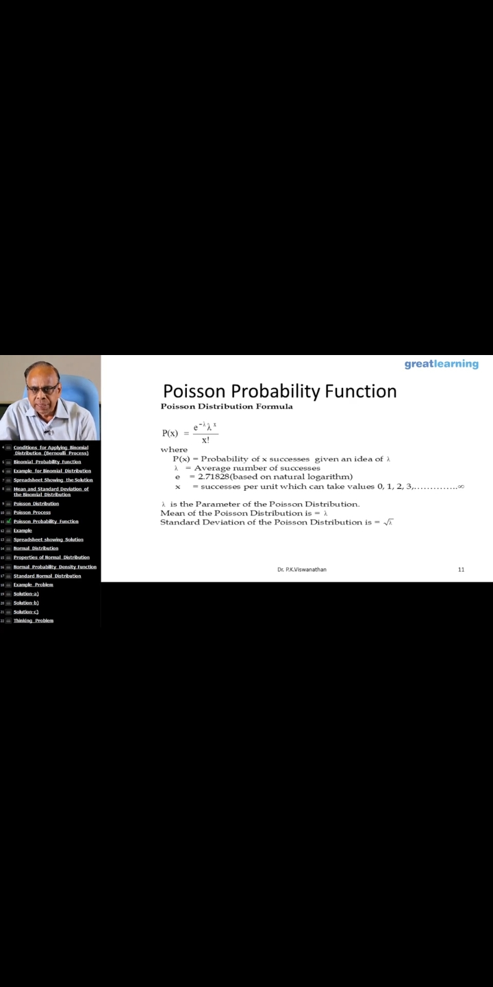

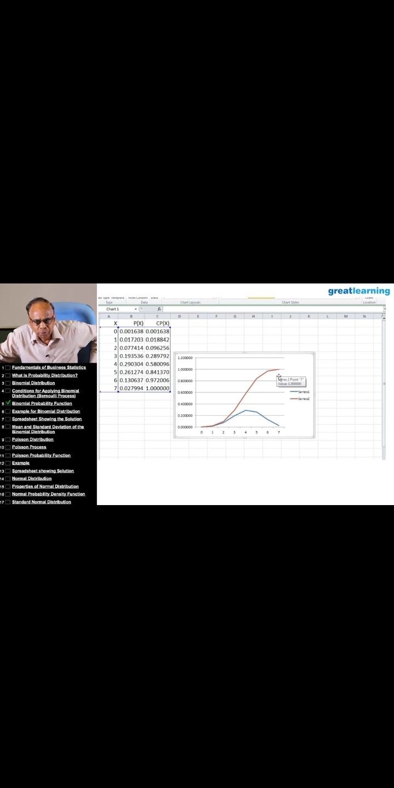

These are the snap shots of today’s sessions.

Online Coding Summary: **Today I had received one program from prof. Shilpa CSE Dept. and other from prof. Venkatesh CSE Dept. The program is mentioned above in the coding challenges(pg.01). I have also uploaded it to my Github repository.**

